**1.Important Points about CheckBox:-**

To group the multiple check boxes, we need to take multiple checkboxes having the same name.

When checkboxes are grouped , user can select 0, more or all checkboxes.

The servlet component should invoke getParameterValues(-) to get check boxes component values.



The array contains values of selected check boxes and non-selected checkboxes. It contains **null** values for non-selected check boxes on user-form . Because to non-selected check boxes, **browser does not place “param name and value” in query string.area**

**Example:**

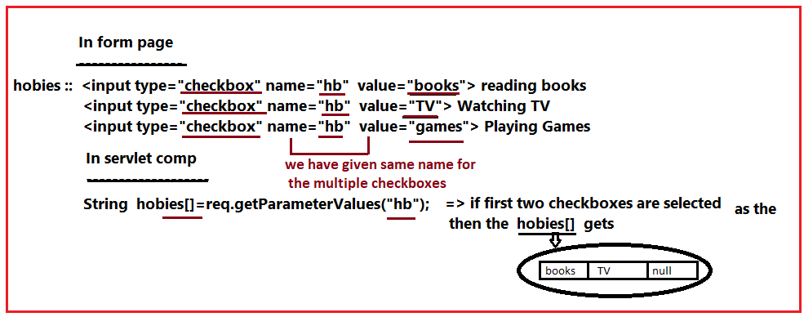

**2. Important Points about Radio Button:-**

To group the multiple Radio buttons, we need to take multiple Radio buttons having the same name.

When radio buttons are grouped , user can select 0 or 1 radio buttons at a time.

Example:--

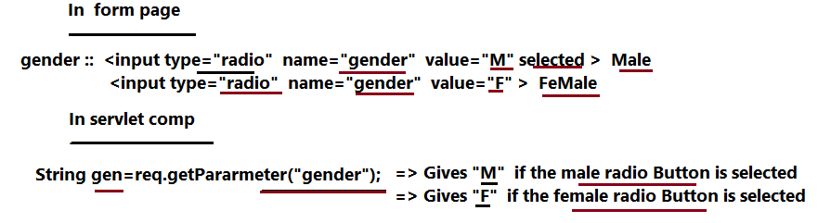

**Note:-**

